CS 4323
Operating Systems
Project

Team members: Michael McQuade

In this project we analyze the scheduling techniques in homework two and three. The scheduling technique in homework two, is a preemptive, round robin scheduling algorithm. The system assigns each process a numerical priority and also has an idle task. The scheduling order of the processes is represented by this Gantt chart:

P1 0-10 | P1 10-15 | Idle 15-25 | P2 25-35 | P3 35-45 | P2 45-50 | P4 50-60 | P4 60-65 | P3 65-75 | P2 75-85 | Idle 85-95 | Idle 95-100 | P5 100-105 | P6 105-115 | P5 115-125

The scheduling technique in homework three is a round robin, multi level queue scheduler with two queues. The scheduling order of the processes is represented by this Gantt chart.

Q1: p1: 0-3 | Q1: p1: 3-6 | Q1: p3: 6-9 | Q1: p1: 9-12 | Q1: p3: 12-15 | Q1: p1: 15-18 | Q2: p2: 18-22 | Q2: p4: 22-26 | Q2: p5: 26-30 | Q2: p2: 30-34

Q2: p4: 34-35 | Q2: p5: 35-39 | Q2: p5: 39-41

Our project was implemented as a React application utilizing node.js. To run the program, node.js need to be installed.
You can install Node.js from the following location: https://nodejs.org/dist/v12.0.0/node-v12.0.0.pkg
After installing, you may need to restart your command line.
You can check that it was successfully installed by typing node -v into a command line and seeing that it returns the currently installed node version.
Once you have it installed, open a command line interface and navigate to the project folder. Then enter “npm install” to install the required packages. Afterwards, start the application with “npm start”.
A web browser will open the project. If not, navigate to http://localhost:3000/ in the browser. The first scheduling technique can be stepped through, one unit at a time or set to automatically step. The second technique will be completed on load.
The source code and screenshots of source code can be located separate to this document. A readme is included which details the steps of running the program (see above).
See next page for program output.
The programs output is below: 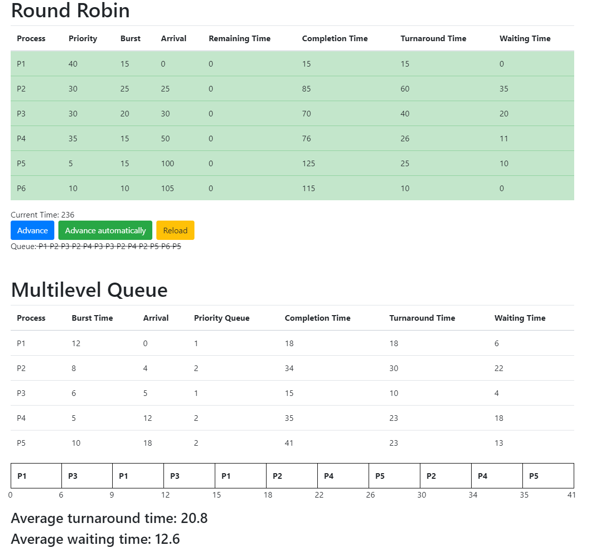

The programs output can be matched to the Gant charts in the introduction.

